PRIME Vision Statement

Introduction:
This document is a vision statement for the PACS-RIS Image Manager for the Enterprise (PRIME) Consortium. The goal of PRIME is the construction of a DICOM, HL7 and IHE compliant open source package of applications that will serve as the core of the Diagnostic Imaging Department’s informatics needs. It will become clear as one reads this document that the design philosophy behind PRIME is to provide image services across multiple enterprises, assuming one has rights in each of them. The need for such a physically distributed yet standard architecture becomes ever clearer as researchers attempt to share data, and administrators strive to centralize imaging services across heterogeneous medical centers under different management. Further, the vision creates multiple new value add markets for entrepreneurs.

Core PRIME functions consists of: accepting orders, scheduling exams, management of the resulting images and reports, issuance of billing information and the administration tools required for both the human and machine resources of the department. The classical architecture for Radiology Informatics systems (A.K.A. PACS-RIS) looks like this:
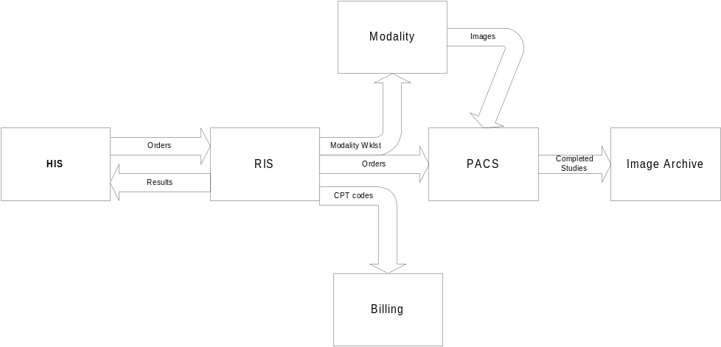

The traditional PACS image workstations communicate with the PACS database via proprietary SQL calls. This requires the healthcare facility to only use workstations from that vendor if they wish to take advantage of the PACS’ intelligence. Purely DICOM compliant workstations can only query studies from the PACS and lose the workflow management that the PACS can provide.

With IHE, the above picture becomes more complex because more interfaces are specified, rather than being hidden. However, that complexity has the potential to pay off in the form of increased freedom. Recent DICOM Supplements and IHE Integration Profiles standardize more of the transactions that are implicit in the above diagram. The additional IHE interfaces are shown in the following architecture:
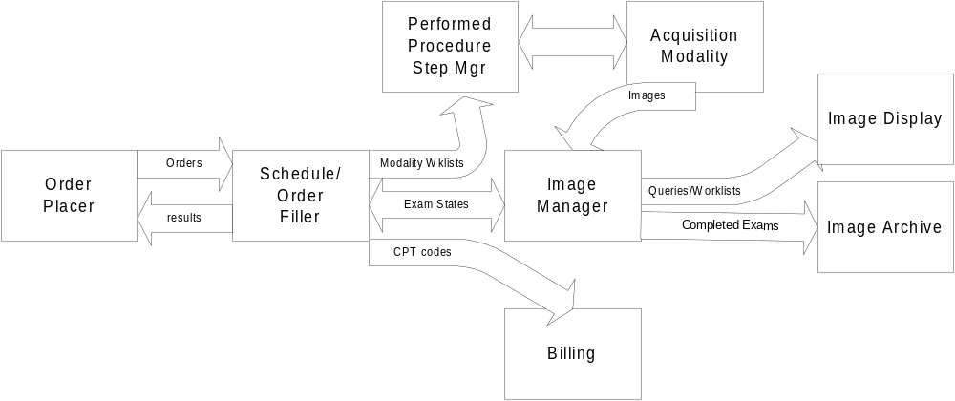

Deliverables:

The PRIME Consortium seeks as its core deliverables the development (or integration) of open source implementations of the following IHE Actors: Scheduler/Order Filler, Performed Procedure Step Manager, Image Manager, Image Display and Image Archive. It will also develop open-source actors for interfaces that are necessary but not yet specified and some operational functions like: user role databases, Web based management tools, the Authenticator and Image Processing Router and API described below.

The following table summarizes the required IHE transaction functionality for each Actor [http://ihe.med.univ-rennes1.fr/ihe/TF/index.php]. The successful actor implementation must be able to pass the MESA tests [Stephen Moore, Mallinkrodt] as well as further tests defined by the Consortium.

Actors | Transactions | Optionality | Section
Department System Scheduler/Order Filler (add Procedure update, Record Audit event) | Patient Registration | R | 4.1
 | Placer Order Management | R | 4.2
 | Filler Order Management | R | 4.3
 | Procedure Scheduled | R | 4.4
 | Modality Worklist Provided | R | 4.5
 | Modality Procedure Step In Progress | R | 4.6
 | Modality Procedure Step Completed | R | 4.7
 | Images Availability Query | O | 4.11
 | Patient Update | R | 4.12
 | Creator Procedure Step In Progress | R | 4.20
 | Creator Procedure Step Completed | R | 4.21
 | Performed Work Status Update | O | 4.42
Image Display (add Q/R PS, Q/R KIN, Q/R evidence, record Audit) | Query Images | R* | 4.14
 | Retrieves Images | R* | 4.16
 | Query Hanging Protocol
Performed Procedure Step Manager (add Record Audit event) | Modality Procedure Step In Progress | R | 4.6
Performed Procedure Step Manager (add Record Audit event) | Modality Procedure Step Completed | R | 4.7
Performed Procedure Step Manager (add Record Audit event) | Creator Procedure Step In Progress | R | 4.20
Performed Procedure Step Manager (add Record Audit event) | Creator Procedure Step Completed | R | 4.21
Image Archive (add Store Commit, Q/R/S PS, Q/R/S KIN, record Audit event) | Modality Images Stored | R | 4.8
 | Query Images | R | 4.14
 | Retrieves Images | R | 4.16
 | Creator Images Stored | R | 4.18
 | Evidence Document Stored | O | 4.43
Image Manager (add Record Audit event) | Procedure Scheduled | R | 4.4
Image Manager (add Record Audit event) | Modality Procedure Step In Progress | R | 4.6
Image Manager (add Record Audit event) | Modality Procedure Step Completed | R | 4.7
Image Manager (add Record Audit event) | Storage Commitment | R | 4.10
Image Manager (add Record Audit event) | Images Availability Query | R | 4.11
Image Manager (add Record Audit event) | Creator Procedure Step In Progress | R | 4.20
Image Manager (add Record Audit event) | Creator Procedure Step Completed | R | 4.21
Image Manager (add Record Audit event) | Performed Work Status Update | O | 4.42

There are components of the high-level architecture that may not yet be specified by any standards group. Examples include a multi-enterprise authentication and authorization manager, and an image processing “Plug In” API (others e.g. a standard method for indicating a study has been dictated, transcribed, or sign-off, beyond returning the report in some form back to the HIS?). Other necessary components include tools for retrieving practice management information, patient flow logic, and user role management. However, in all cases authors should seek to extend existing standards whenever possible rather then implementing a custom solution.

Finally, it may also be the case that specifying the interfaces required to operate several different departments may elucidate other interfaces/requirements not indicated in the above diagram.

Architecture:

- Anatomy of IHE Scheduler/Order-Filler, PPS-Manager, Image-Manager, Image-Archive Actors:

The fundamental tenets of PRIME Actor modules are that they are maintainable, scalable, reliable, interchangeable and largely reusable. To achieve this requires an agreeable design platform and strategy that permits flexibility, yet also fosters a common design among PRIME programmers which shortens the learning curve for one to understand Actors written by other authors. For demonstrations and collaborative purposes, most PRIME Actors should be able to run on a single server perform, either with distinct Dbase instances or with co-joined Dbases where that makes sense (e.g. if there is considerable schema overlap). Schematically we have the following:
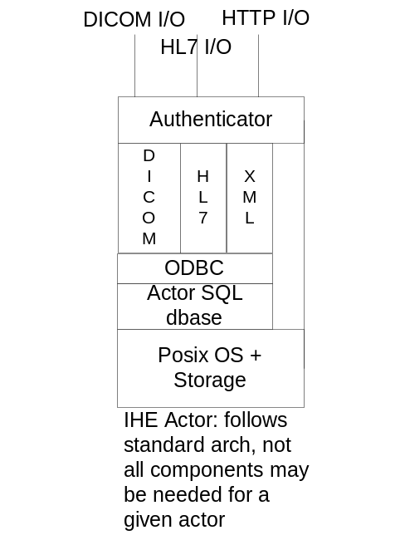

The preferred “reference” installation (for testing and demonstration purposes) is on a single POSIX compliant Operating System (i.e. *NIX, Mac OS X, or POSIX enabled Windows). The use of POSIX guarantees programmers a consistent system call API with minimal use of conditional compilation. In addition, POSIX provides for a wealth of standard inter-process communication methods and robust thread management.

Further, a given PRIME Actor should use a single PostGresSQL (or similarly featured Dbase) instance for its functionality. Several Actors may share a single Dbase instance if the schema overlap is significant. The Dbase should at least support rollback and row level locking. To avoid over-constraining the design, we do not specify exactly what Dbase should be chosen. However, to avoid coding specific to MySQL, PostGresSQL or other APIs an ODBC interface to the DICOM, HL7 and XML parsers shall be used to reduce coding lock-in to a specific Dbase vendor.

To avoid the requirement for an external HL7/DICOM broker, each Actor will internally support the full protocol set required of it in the IHE specification. For instance, an Image Manager may need to accept HL7 orders from the Order Filler, but also need to profile incoming DICOM exams from an imaging modality. For this reason both HL7 and DICOM parsers should be present on this Actor. The languages used for these parsers are up to the developer, but it is to be hoped that they will be object oriented; Java, Object PERL or Python are encouraged.

Further, each Actor should support a Management Interface (to define resources, permitted users for the Actor, etc) via a XML/HTML based protocol. The transaction requirements for the DICOM/HL7 interfaces are implied from the IHE specification. The human, Web based management requirements will be discussed below.

Finally, there is an authentication layer for each Actor that uses session based certificates, issued to user agents by a trusted certificate authority, to control agent (human or software) access. The authenticator will be covered further in the next section.

- Session based Certificate Authentication and Authorization

Imagine that a radiologist is hired to read cases from multiple hospitals and HMOs. However, the administrations of each of these business units may not be friendly with one another – so data is not shared directly among the medical centers. How can each site restrict the access to its systems, yet a third party can read cases at some or all of them? The solution is to divide the security responsibilities. The IT administrators at each site define the permitted agents and their roles and grant privileges based on those roles. For instance, an Order Placer (human or sware) can place, cancel and change orders on the Order Filler Actor. So the IT admin’s job is to define (i.e. maintain the Access Control Lists) for all the allowed Order Placer’s that can talk to his Order Filler But how can the IT admin and his Actor trust the identity of who is connecting?

Enter a trusted third party certificate authenticator – and a component that PRIME authors will have to create (with due attention paid to current DICOM work). The IT administrator certifies his Actors with the Authentication Actor. Role playing agents (such as human radiologists, or other sware agents) do likewise. Upon logon to her Image Display Actor, the radiologist must authenticate to it. In doing so the Authenticator returns a trusted certificate that encodes her identity. When she points her Image Display Actor at an Image Archive and requests a study, the Archive need only validate the certificate and check the local ACL Dbase for the presence or absence of the requested role for the agent. If everything checks out, a session is created for the duration of the network connection. If the connection is broken the process is repeated. Messages between Actors and the Authenticator should be encrypted and supported across all necessary protocols. [Note: New market potential. A single company could host an Authenticator supporting many different users and organizations, and charge annually for the service. Control over site data is still maintained locally via ACLs configured on each Actor.]

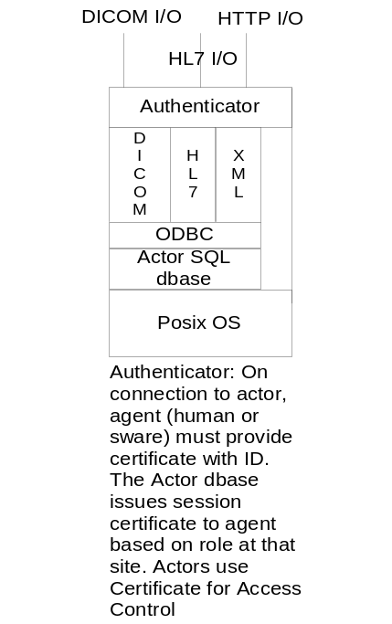

- Human Web Management Interface

At some point each actor will require configuration, or perhaps manual order entry, patient merging, exam merging, etc. The XML/HTML web management logic for each actor should be bundled into the Actor itself. Thus a user need only point their SSL equipped browser at the IP address of the Actor to perform any data input and editing for which the user has role privileges. For instance, if a user has Scheduler privileges, they should be able to log into the Order Filler and create, view, cancel and update patient appointments. Ideally, most of the logic would reside on the Actor, with minimal applet requirements on the client side.
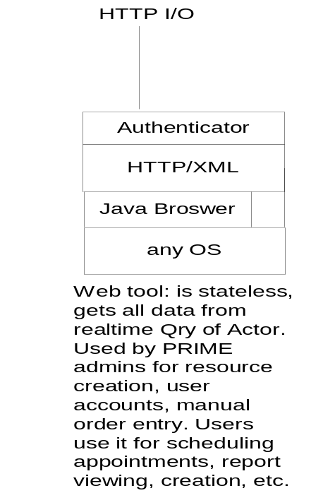

The Web management interface should support at least the following functions on the completed PRIME application:

- creation and management of users using a role based privilege assignment. Assume that PRIME can span multiple medical centers and that a user can have different/multiple privileges/IDs at each site. [Implications for Authenticator.]

- creation and management of patients. Assume that PRIME can span multiple medical centers and that the same patients can have different IDs in each site. [Implies a MPI.]

- creation, configuration and management of DICOM/HL7 resources and privileges in the system. This would include management of “user” roles for these agents.

- creation/configuration of new exams codes, linking to their CPT values, any preparation instructions and typical time/resources needed for the exam (needed for the scheduling module)

- ability to perform manual exam scheduling using a first available and/or best-fit time algorithm

- ability to perform exam status changes (arrival, cancel, complete, preliminary report, finalized report)

- ability to support exam reporting using via a simple Web interface [Note: less important if DICOM SR is used in the Image Display Application.] Reports would be stored to any or all of: HIS/EMR, PRIME Dbase, the DICOM headers in the Image Archive.

- exam QA tools to correct demographic errors, image/exam merge and move, patient merges and move, etc

- Audit management. Configuration and retrieval of audit data

A potential Dbase schema and interface examples to achieve many of the above goals is shown in Figures 1-3 [Langer, Journal of Digital Imaging; 2002(2)].

- IHE Image Display Actor(s)

Given the likelihood this Actor will invoke remote image processors to perform 3D or greater operations, registration, CAD, etc, it is anticipated that its architecture will be slightly different from the majority of IHE Actors. Also, it is preferable that the Display Actor run as a client/server application to a remote Dbase so image display is local while user preferences (e.g. hanging protocols, comparison rules) can be stored on a remote server.
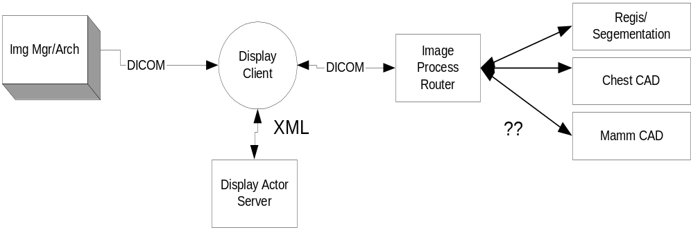

From the Figure above, one can see the process flow:
  - The user logs in on the client and fetches their preferences (hanging protocols, comparison rules) from the Display Actor Server
  - The user then pulls exams from an Image Manager or Archive they have privileges for
  - The exam is pulled along with any priors and hung
  - The user chooses to use a CAD tool, a CT series (for example) is highlighted and sent to the Image Processing Router
  - The Router analyzes the DICOM header and decides the proper processing “Plug In” to use based on a yet to be defined protocol and API
  - Results are returned in standard DICOM (Processing and/or Presentation objects)

Note that we have assumed three new elements in this portrayal: a simple image processing router, the existence of image processing “Plug Ins” that support a common API and the API itself. This is one of the new components that PRIME authors will need to invent. It is to be hoped that the API once published, may join the DICOM standard and image processing vendors may wrap their existing executables in it to extend their products to the PRIME environment. [Note: This creates an entirely new market; PRIME Image Processing Plug Ins for image fusion, registration, segmentation, high dimension modeling, CAD, etc.] In other respects, the Display Actor should look like other Actors except the Dbase layer might live on a remote server and its place taken by a local image display engine.

When completed the PRIME Image Display client application should be able to run on all major computing platforms (Windows, *NIX, Macintosh), communicate in a purely DICOM manner with other Actors and via XML to the Image Display Actor Server. While we do not specify a development platform, these requirements place strict limits upon what toolkits could be used.

There are likely to be 3 families of Display applications that may or may not be one application that morphs its appearance depending on configuration and use. Workstations should support internationalization as well.

  - QA Station: The technologist needs to be able to adjust, rotate, flip, delete, move, etc. images in an exam and indicate it is ready for interpretation.

  - Diagnostic Station: needs to be able to get the next examination for interpretation that fits a variety of criteria depending on the exam status and other criteria (e.g. any stat exam, the oldest exam of a modality and/or body part and/or procedure code and/or AETitle). It should also support reporting via dictation phone, speech recognition, or structured reporting application.

  - Clinical display station: should allow the referring physician to review images and reports, as well as annotation, key images etc.

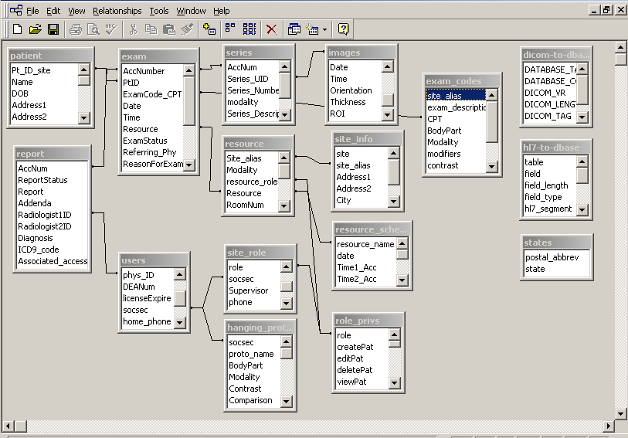
Fig. 1 An example Order Filler Dbase Schema

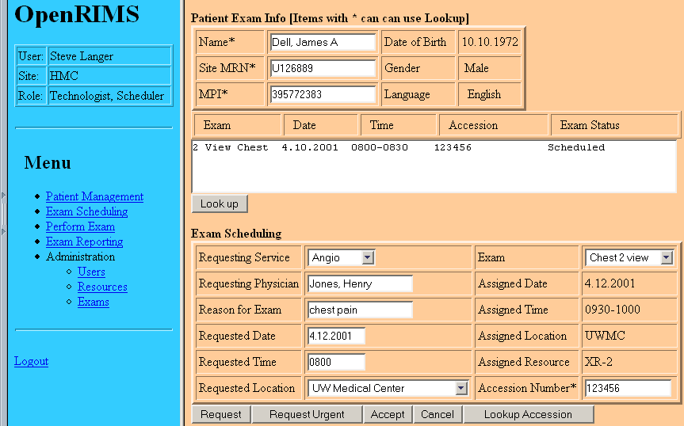

Fig. 2 Scheduling an Exam

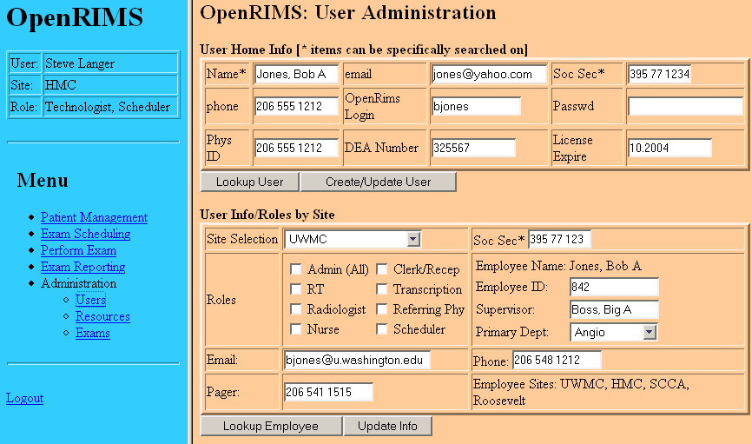

Fig. 3 Creating users on the System and assigning their rights.

